**Supplementary Methods, Statistical and Genomic Analyses**

Reproducibility

In seeking to explore the importance and applicability of these results it is critical that others continue replicate model results before they can be used in the clinical setting. To accompany this report, help with replication and extension of our work, the code has been made publically available for model I and model II online.

Database

The subjects in the present study were participants in *Invecchaiare in Chianti* (Aging in Chianti, “InCHIANTI Study”). InCHIANTI is a prospective population based study of 1,453 adults aged 20-102 randomly selected from two towns in Tuscany, Italy using a multistage stratified sampling at baseline from 1998 to 20001. All aspects of the InCHIANTI research were approved by the ethics committees at the institutions responsible for data collection.

Definitions used to establish phenotype sub-groups in this study

**Cognitive impairment – mild neurocognitive disorders**

Evidence of modest cognitive decline from a previous level of performance in one or more cognitive domains (complex attention, executive function, learning and memory, language, perceptual motor, or social cognition) with a modest impairment in cognitive performance by standardized neuropsychological testing or clinical assessment in absence of a diagnosis of dementia2,34.

**Frailty**

The operational definition for frailty is defined as a clinical syndrome condition including 3 out of the 5 criteria related a physical phenotype including: 1) weak muscle strength (grip strength), 2) slow gait speed, 3) unintentional weight loss, 4) exhaustion and low physical activity5. Pre-frailty includes 1 or 2 of the criteria is present, identifying a sub-group of individuals potentially progressing to frailty5.

**Cognitive Frailty**

A syndrome in older adults with evidence of both physical frailty and cognitive impairment without a clinical diagnosis of Alzheimer’s Disease or other dementia6.

Phenotypic classification for this study

Model I

Participants with an MMSE normal cognition 24-30 and cognitive decline ≤ 237–9. In this study frailty is characterized by individuals with one or more of the frailty criterion5. Cognitive frailty is defined as individuals with cognitive decline and one or more of frailty criterion10.

* Robust with no physical frailty and absence of cognitive decline
* Robust with no physical frailty with cognitive (MMSE = ≤ 23)
* Frail (≥ 1 criteria) and absence of cognitive decline
* Frail (≥ 1 criteria) and cognitive decline (MMSE = ≤ 23)

Model II

Participants that completed the MMSE with additional neuropsychiatric testing Trail Making Test, Part A and B (TMT) to define cognitive decline and cognitive frailty10,11. TMT cut off scores for cognitive decline are based on cut off norms established by Ashendorf et al., 2008.

* Robust with no physical frailty and absence of cognitive decline
* Robust with no physical frailty with cognitive decline (Trail A ≥ 78, Trail B ≥ 106)
* Frail (≥ 1 criteria) and cognitive decline (Trail A ≥ 78, Trail B ≥ 106)
* Frail (≥ 1 criteria) and cognitive decline (Trail A ≥ 78, Trail B ≥ 106)

Laboratory assay methods

At the baseline survey, most of the participants performed 24-hour urine collection early in the morning mid-stream sample urine for the routine examination. Total urinary polyphenols were measured at the Department of Food Science and Technology, School of Pharmacy, University of Barcelona, Spain. Prior to blood collection all participants consumed a diet free of meat and fish. Participants donated fasting blood samples for routine blood examinations. Blood collection was performed with the standard procedure method to prevent red cell hemolysis. The blood collection included two sets of collection tubes: one for routine tests and second for collecting specimens including serum, plasma, DNA for the biological bank. All routine blood tests, performed in the Laboratory of Clinical Chemistry and Microbiological Assays, Annunziata Hospital in Florence, Italy. Plasma fatty acids (FAs) were measured by the Section of Gerontology and Geriatrics, Department of Clinical and Experimental Medicine, Perugia, Italy. The technique used was gas chromatography with a fused silica capillary column to achieve the optimum separation of the different fatty acids.

Software for analyses

All statistical analyses were carried out using R V. 3.2.1. R is a free, open-source software that provides many statistical and graphic techniques. R packages used included ‘glm2’-Fitting Generalized Linear Models, ‘Ordinal’-Regression Models for Ordinal Data, and ‘xgboost’-Extreme Gradient Boosting12–14. The software package PLINK, an analysis toolset was used for the management of genotype data and basic associating testing15,16.

Model generation

The predictive genetic and laboratory biomarkers were identified in a comprehensive systematic review and analyzed using an Extreme Gradient Boosting (xgboost) in R14. While boosting was initially developed for machine learning, ‘xgboost’ in R is based in boosted trees. Xgboost is an open source tool and a variant of the gradient boosting machine and uses a tree based model. Xgboost is used in this study for a supervised learning problem where the variables identified from the systematic review are used to predict three phenotypes cognitive decline, physical frailty, and cognitive frailty.

Evaluation of the model

With the use of any predictive model in machine learning there is a chance for inflated risk of capitalizing on chance features (overfitting) in the data. Overfitting of the integrative model was mitigated in two ways: 1) having a distinct training and validation process for the model and 2) using xgb in R which has a built-in parameter settings for selection to reduce poor predictive performance. *Internal validation:* A randomly assigned training subset was used to validate the model within the InCHIANTI cohort *in silico* (via simulation).

Calibration of the model

Parameter estimates for each predictive factor and associated descriptive statistics was evaluated to provide biological insight into the underpinnings of the classification algorithm. We first evaluated the calibration by partitioning the data into 5, 10, 20, 30, 40, 50, 75, 100 and 200 groups and then ran the calibration test. Next, we repeated tests for all possible values between 5-200 groups and evaluated the distribution of the test statistic. The best prediction thresholds were determined using AUC, 87.7% for Model I and 86.4% for Model II. Population predictive features by phenotype ranked by gain for Model I are presented in Tables 4-6 and Model II Tables 7-9.

Genetic Data

Genotypic data was generated at the National Institute on Aging’s Laboratory of Neurogenics. Samples of genomic DNA extracted from leukocytes17. Genotypic data used for the model were extracted out of the binary Plink files from the InCHIANTI database. SNPs which could not be identified in the binary files were extracted from genotype imputed files, genotype imputation was completed with Minimac (V2). The SNPs included meet the following standard: per variant and per sample missingness < 5%, European ancestry, MAF < 0.001 and a rsq < 0.3. Additionally, Samples were filtered for 95% or greater genotyping call rate, no ancestry outliers, and no sex discrepancies.

Biomarker Selection

Laboratory and genetic biomarkers were selected based on the results of a systematic review of the literature performed using the following online databases: PubMed, Embase, Scopus, Web of Science, LILACS, Gene Indexer, and GWAS Central. The systematic review findings and results tables are available in a previous publication.18

**Supplementary Data Table I: Laboratory values as they appear in the InCHIANTI** **Datasets by Clinical Category**

|  |  |  |
| --- | --- | --- |
| **Inflammatory/Immunity** | **Nutrient Biomarker** | **Lipid Metabolism** |
| BL Uric acid (mg/dL) | BL Omega-3 fatty acids as % of total fatty acid area | BL Lipids: total cholesterol (mg/dL) |
| BL Urinary cortisol (µg/mL) | BL Omega-3 plasma fatty acid weight (mg/L) | BL Lipids: HDL cholesterol (mg/dL) |
| BL 24-hour urinary cortisol (µg/24 hours) | BL Omega-3 fatty acids as % of total fatty acid weight | BL Lipids: triglycerides (mg/dL) |
| BL C-reactive protein - low sensitivity (µg/mL) | BL Omega-3 fatty acids as % of total fatty acid mols | BL Lipids: LDL cholesterol (mg/dL) |
| BL C-reactive protein - high sensitivity (µg/mL) | BL Omega-6 fatty acids as % of total fatty acid area | BL Lipoprotein(a) (mg/dL) |
| BL Interleukin-6 via ELISA ultrasensitive (pg/mL) | BL Omega-6 plasma fatty acid weight (mg/L) |  |
| BL IL-6 high-sensitivity ELISA calculated from ELISA ultrasensitive (pg/mL) | BL Omega-6 fatty acids as % of total fatty acid weight | **Metabolomics(plasma lipids)** |
| BL Soluble IL-6 receptor via ELISA (ng/mL) | BL Omega-6 fatty acids as % of total fatty acid mols | BL Fatty acid C16:0 (palmitiA91:A116c) area |
| BL Interleukin-10 via ELISA (pg/mL) | BL Ratio of Omega-6:Omega-3 as % of total fatty acid area | BL Fatty acid C16:0 (palmitic) area |
| BL Interleukin-1 receptor antagonist via ELISA ultrasensitive (pg/mL) | BL Ratio of Omega-6:Omega-3 as % of total fatty acid weight | BL Fatty acid C16:0 as % of total fatty acid area |
| BL Interleukin-1B via ELISA (pg/mL) | BL Ratio of Omega-6:Omega-3 as % of total fatty acid mols | BL Fatty acid C16:0 weight (mg/L) |
| BL Interleukin-18 via ELISA ultrasensitive using plasma (pg/mL) | BL Vitamin B6 via high performance liquid chromatography (ng/mL) | BL Fatty acid C16:0 as % of total fatty acid weight |
| BL Transforming growth factor-B1 (pg/mL) | BL Vitamin B6 via high performance liquid chromatography (nmol/L) | BL Fatty acid C16:0 (µmol/L) |
| BL Tumor necrosis factor-a via multiplex technology (pg/mL) | BL Vitamin E gamma tocopherol, high performance liquid chromatography (µmol/L) | BL Fatty acid C16:0 as % of total fatty acid mols |
| BL Soluble TNF-a receptor I via quantitative sandwich EIA (pg/mL) | BL Vitamin E alpha tocopherol, high performance liquid chromatography (µmol/L) | BL Fatty acid C20:0 (arachidic) area |
| BL Soluble TNF-a receptor II via quantitative sandwich EIA (pg/mL) | BL Vitamin E gamma tocopherol, high performance liquid chromatography, assay #2 (µmol/L) | BL Fatty acid C20:0 as % of total fatty acid area |
| BL TNF-related apoptosis-inducing ligand (pg/mL) | BL Vitamin E alpha tocopherol, high performance liquid chromatography, assay #2 (µmol/L) | BL Fatty acid C20:0 weight (mg/L) |
| BL Interleukin-8 via Bio-Plex (pg/mL) | BL Beta-carotene via high performance liquid chromatography (µmol/L) | BL Fatty acid C20:0 as % of total fatty acid weight |
| BL Interleukin-12 via Bio-Plex (pg/mL) | BL Lycopene via high performance liquid chromatography (µmol/L) | BL Fatty acid C20:0 (µmol/L) |
| BL Monocyte chemoattractant protein-1 via Bio-Plex (pg/mL) | BL Total proteins (g/dL) | BL Fatty acid C20:0 as % of total fatty acid mols |
| BL Macrophage inflammatory protein-1b via Bio-Plex (pg/mL) | BL Albumin (%) | BL Fatty acid C20:5 n-3 cis (eicosapentaenoic, EPA) area |
| BL Serum cortisol (µg/dL) |  | BL Fatty acid C20:5 n-3 as % of total fatty acid area |
| BL Serum cortisol (nmol/L) |  | BL Fatty acid C20:5 n-3 weight (mg/L) |
| BL Dehydroepiandrosterone sulfate (µg/dL) |  | BL Fatty acid C20:5 n-3 as % of total fatty acid weight |
| BL Dehydroepiandrosterone sulfate (nmol/L) |  | BL Fatty acid C20:5 n-3 (µmol/L) |
| BL Cortisol:DHEAS ratio (based on nmols) |  | BL Fatty acid C20:5 n-3 as % of total fatty acid mols |
| BL Soluble CD14 via ELISA (ng/mL) |  | BL Fatty acid C22:0 (behenic) area |
| BL Fibrinogen (mg/dL) |  | BL Fatty acid C22:0 as % of total fatty acid area |
| BL Erythrocyte sedimentation rate (ESR) (mm/hour) |  | BL Fatty acid C22:0 weight (mg/L) |
| BL Homocysteine via FPIA analysis (µmol/L) |  | BL Fatty acid C22:0 as % of total fatty acid weight |
| BL Resistin via EIA (ng/mL)- |  | BL Fatty acid C22:0 (µmol/L) |
| BL Adiponectin via RIA (µg/mL)-(metabolic function) |  | BL Fatty acid C22:0 as % of total fatty acid mols |
| BL Advanced glycation endproduct (AGE): Carboxymethyl-lysine (ng/mL) |  | BL Fatty acid C24:0 (lignoceric) area |
| BL Alpha-1 globulin (%) |  | BL Fatty acid C24:0 as % of total fatty acid area |
| BL Alpha-2 globulin (%) |  | BL Fatty acid C24:0 weight (mg/L) |
| BL Alpha-2-macroglobulin (mg/dL) |  | BL Fatty acid C24:0 as % of total fatty acid weight |
| BL Beta globulins (%) |  | BL Fatty acid C24:0 (µmol/L) |
| BL Endogenous secretory receptor for AGEs (ng/mL) |  | BL Fatty acid C24:0 as % of total fatty acid mols |
| **Renal/Electrolyte** | **Hematology/Liver** | **Endocrine/Hormones** |
| BL Na+ (mEq/L) | BL White blood cells (WBC) (n, K/µL) | BL Blood glucose (mg/dL) |
| BL Ca++ (mg/dL) | BL Neutrophils (n, K/µL) | BL 25(OH)-D (25-hydroxyvitamin D) via RIA (nmol/L) |
| BL Urinary creatinine (mg/dL) | BL Lymphocytes (n, K/µL) | BL Parathyroid hormone, two-site immunoradiometric assay (pg/mL) |
| BL 24-hour urinary creatinine (mg/24 hours) | BL Monocytes (n, K/µL) | BL Thyroid stimulating hormone, TSH (mIU/L) |
| BL Creatinine clearance, 24-hr urine (mL/minute) | BL Neutrophils (%) | BL Free thyroxine, fT4 (ng/dL) |
| BL Urinary Ca (mmol/L) | BL Lymphocytes (%) | BL Plasma insulin via RIA (mIU/L) |
| BL Urinary Na (mmol/L) | BL Monocytes (%) | BL Total testosterone (ng/mL) |
| BL Urine glucose (mg/dL) | BL Red blood cells (RBC) (n, millions/µL) | BL Total testosterone (nmol/L) |
| BL Urine proteins (mg/dL) | BL Hemoglobin (g/dL) | BL Free testosterone (ng/dL), Vermeulen |
| BL Urine hemoglobin (mg/dL) | BL Hematocrit (%) | BL Free testosterone (nmol/L), Vermeulen |
| BL Urine ketones (mg/dL) | BL Mean corpuscular volume (MCV) (fL) | BL Estradiol via radioimmunoassay (pg/mL) |
| BL Urine bilirubin (mg/dL) | BL Mean corpuscular hemoglobin (MCH) (pg) | BL Estradiol via radioimmunoassay (nmol/L) |
| BL Urine urobilinogen (mg/dL) | BL MCH concentration (MCHC) (g/dL) | BL C-terminal telopeptide of type-1 collagen (ng/mL) |
| BL Urine nitrites | BL Red cell distribution width (RDW) (%) | BL Total insulin-like growth factor-1, serum, immunoradiometric assay (ng/mL)-(IGFBP1) |
| BL Serum creatinine (mg/dL) | BL Mean platelet volume (MPV) (fL) | BL IGF binding protein-3, serum, immunoradiometric assay (ng/mL) ***corrected*** |
| BL Blood urea nitrogen (mg/dL) | BL Ferritin (ng/mL) | BL IGF binding protein-3, serum, immunoradiometric assay (nmol/L) |
| BL Creatine phosphokinase (U/L) | BL Folate via RIA (ng/mL) |  |
| BL Cystatin C (mg/L) | BL Folate via RIA (nmol/L) |  |
|  | BL Vitamin B12 via RIA (pg/mL) |  |
|  | BL Vitamin B12 via RIA (pmol/L) |  |
|  | BL Methylmalonic acid(methylmalonic aciduria), MMA (µmol/L) |  |
|  | BL Soluble transferrin receptor (nmol/L) |  |
|  | BL Soluble transferrin receptor (mg/L) |  |
|  | BL GOT (also known as AST) (U/L) |  |
|  | BL GPT (also known as ALT) (U/L) |  |
|  | BL Gamma glutamyl transferase (U/L) |  |
|  | BL Retinol via high performance liquid chromatography (µmol/L) |  |

**Supplementary Data Table II: Variants included in the Genomic Risk Score GRS calculations and individual effect estimates of single variates for predictive modeling. Phenotype association is based on the findings from the systematic review and the relationship found between variant and disease outcome.**

|  |  |  |  |  |
| --- | --- | --- | --- | --- |
| Variant Name-Allele | Allele Frequency  (%) | Gene/Closest RefSeq Gene | Variant Detail-dbSNP | Phenotype Association |
| rs1048945_C | 1.3 | APEX1 | rs1048945 C/G Ancestral: G Minor: C | Cognition |
| rs1052133_G | 20.6 | OGG1 | rs1052133 C/G Ancestral: C Minor: G | Cognition |
| rs1064039_T | 19.0 | CST3 | rs1064039 A/G Ancestral: G Minor: T | Cognition |
| rs10793294_C | 21.7 | GAB2 | rs10793294 A/C Ancestral: G Minor: C | Cognition |
| rs10883631_G | 48.4 | BTRC | rs10883631 A/G Ancestral: G Minor: A | Frail |
| rs10883642_G | 48.4 | BTRC | rs10883642 A/G Ancestral: A Minor: A | Frail |
| rs11225434_C | 47.9 | WTAPP1 | rs11225434 C/T Ancestral: T Minor: C | Cognition |
| rs113263161_A | 10.4 | **CCRL2**/LOC102724297 | rs113263161 A/G Ancestral: G Minor: A | Cognition |
| rs1133174_A | 41.0 | SORL1 | rs1133174 A/G Ancestral: G Minor: A | Cognition |
| rs11574428_A | 10.2 | CCRL2 | rs11574428 A/T Ancestral: T Minor: A | Cognition |
| rs11575821_A | 11.4 | **CCRL2**/LOC102724297 | rs11575821 A/G Ancestral: G Minor: A | Cognition |
| rs1207568_A | 19.4 | KLOTHO | rs1207568 C/T Ancestral: C Minor: A | Cognition |
| rs13113697_T | 27.2 | **HS3ST1**/LOC107986178 | rs13113697 G/T Ancestral: G Minor: T | Cognition |
| rs1468063_T | 12.4 | FAS | rs1468063 A/G Ancestral: G Minor: T | Cognition |
| rs1566728_C | 14.1 | PTPRJ | rs1566728 A/G Ancestral: G Minor: C | Frail |
| rs16944_A | 33.4 | IL1B | rs16944 A/G Ancestral: A Minor: A | Cognition |
| rs1799990_G | 30.9 | PRNP | rs1799990 A/G Ancestral: A Minor: G | Cognition |
| rs1800629_A | 12.3 | TNF | rs1800629 A/G Ancestral: G Minor: A | Cog/Frail |
| rs1800764_C | 47.6 | ACE | rs1800764 C/T Ancestral: C Minor: T | Cognition |
| rs1800796_C | 5.0 | IL6 | rs1800796 C/G Ancestral: G Minor: C | Cog/Frail |
| rs1801394_G | 43.9 | MTRR | rs1801394 A/G Ancestral: A Minor: G | Frail |
| rs2047812_A | 14.8 | PTPRJ | rs2047812 C/T Ancestral: C Minor: A | Frail |
| rs2227729_G | 7.5 | VTN | rs2227729 C/T Ancestral: C Minor: G | Frail |
| rs2228145_C | 38.0 | IL6-R | rs2228145 A/C/T Ancestral: A Minor: C | Cognition |
| rs2228467_C | 8.2 | CCL4 | rs2228467 C/T Ancestral: T Minor: C | Cognition |
| rs2229238_T | 16.9 | IL6-R | rs2229238 C/T Ancestral: C Minor: T | Cognition |
| rs2267163_T | 36.5 | TCN2 | rs2267163 C/T Ancestral: C Minor: T | Frail |
| rs2283368_C | 12.3 | KLOTHO | rs2283368 C/T Ancestral: T Minor: C | Cognition |
| rs2465481_A | 47.0 | GNAI1 | rs2465481 C/T Ancestral: C Minor: A | Cognition |
| rs2714465_G | 45.0 | GNAI1 | rs2714465 A/G Ancestral: A Minor: G | Cognition |
| rs3092960_A | 10.7 | CCR2 | rs3092960 A/G Ancestral: G Minor: A | Cognition |
| rs3131609_C | 32.8 | USP50 | rs3131609 A/G Ancestral: A Minor: C | Cognition |
| rs360722_A | 16.9 | IL18 | rs360722 C/T Ancestral: T Minor: A | Frail |
| rs3865444_A | 27.1 | CD33 | rs3865444 G/T Ancestral: G Minor: A | Cognition |
| rs4147929_A | 19.3 | ABCA7 | rs4147929 A/G Ancestral: G Minor: A | Cognition |
| rs429358_C | 6.9 | APOE | rs429358 C/T Ancestral: C Minor: C | Cognition |
| rs4316_T | 38.1 | ACE | rs4316 C/T Ancestral: C Minor: T | Cognition |
| rs4845622_C | 38.6 | IL6R | rs4845622 A/C Ancestral: A Minor: C | Cognition |
| rs4968782_G | 41.0 | **ACE** | rs4968782 A/G Ancestral: G Minor: G | Cognition |
| rs55636820_A | 6.0 | BIN1 | rs55636820 A/G Ancestral: G Minor: A | Cognition |
| rs562020_A | 34.6 | KLOTHO | rs562020 C/T Ancestral: T Minor: A | Cognition |
| rs573521_A | 47.2 | MMP3 | rs573521 C/T Ancestral: C Minor: A | Cognition |
| rs5744256_G | 18.3 | IL18 | rs5744256 C/T Ancestral: T Minor: G | Frail |
| rs603050_T | 31.3 | WTAPP1 | rs603050 A/G Ancestral: G Minor: T | Cognition |
| rs611646_T | 48.6 | ATM | rs611646 A/T Ancestral: A Minor: A | Frail |
| rs61812598_A | 37.9 | IL6-R | rs61812598 A/G Ancestral: G Minor: A | Cognition |
| rs6441977_A | 10.2 | CCRL2 | rs6441977 A/G Ancestral: G Minor: A | Cognition |
| rs650108_A | 30.1 | MMP3 | rs650108 A/G Ancestral: G Minor: A | Cognition |
| rs6762266_C | 10.4 | **CCRL2** | rs6762266 C/T Ancestral: T Minor: C | Cognition |
| rs679620_T | 46.7 | MMP3 | rs679620 A/G Ancestral: G Minor: T | Cognition |
| rs6808835_T | 10.5 | CCRL2 | rs6808835 G/T Ancestral: T Minor: T | Cognition |
| rs7110631_C | 31.2 | **PICALM** | rs7110631 C/G Ancestral: G Minor: C | Cognition |
| rs7396366_C | 36.0 | AP2A2 | rs7396366 G/T Ancestral: T Minor: C | Cognition |
| rs7412_T | 6.6 | APOE | rs7412 C/T Ancestral: C Minor: T | Cognition |
| rs7497104_T | 28.6 | MYO9A | rs7497104 C/T Ancestral: T Minor: T | Cognition |
| rs7926920_A | 46.9 | WTAPP1 | rs7926920 A/G Ancestral: G Minor: A | Cognition |
| rs9267487_C | 6.5 | DDX39B | rs9267487 C/T Ancestral: T Minor: C | Frail |
| rs9349407_C | 24.5 | CD2AP | rs9349407 C/G Ancestral: G Minor: C | Cognition |
| rs948399_C | 26.9 | MMP3 | rs948399 C/T Ancestral: T Minor: C | Cognition |
| rs9527025_C | 14.8 | KLOTHO | rs9527025 C/G Ancestral: C Minor: C | Cognition |
| rs3219484_T | 3.8 | MUTYH | rs3219484_ A/G Ancestral: G Minor: T | Cognition |
| rs12752888_C | 26.8 | **ACOT11**/LOC105378734 | rs12752888 C/T Ancestral: T Minor: C | Cognition |
| rs1539053_A | 45.6 | DAB1 | rs1539053 C/T Ancestral: T Minor: G | Cognition |
| rs3811448_A | 19.3 | TDRD10 | rs3811448 A/G Ancestral: A Minor: A | Cognition |
| rs4129267_T | 37.9 | IL6-R | rs4129267 C/T Ancestral: C Minor: T | Cognition |
| rs915179_G | 36.0 | LMNA | rs915179 A/G Ancestral: G Minor: A | Cognition |
| rs9919256_A | 13.7 | LMNA | rs9919256 A/G Ancestral: A Minor: A | Cognition |
| rs6131_T | 19.4 | SELP | rs6131 A/G Ancestral: A Minor: T | Frail |
| rs3818361_A | 19.5 | CR1 | rs3818361 C/T Ancestral: C Minor: A | Cognition |
| rs1260326_C | 46.3 | GCKR | rs1260326 C/T Ancestral: C Minor: T | Frail |
| rs744373_G | 28.2 | **BIN1** | rs744373 C/T Ancestral: T Minor: G | Cognition |
| rs7561528_A | 31.2 | **BIN1**/LOC105373605 | rs7561528 A/G Ancestral: A Minor: A | Cognition |
| rs11894266_C | 43.5 | **SSB** | rs11894266 C/T Ancestral: C Minor: T | Cognition |
| rs6747918_A | 49.2 | CASP8 | rs6747918 A/G Ancestral: A Minor: A | Frail |
| rs2929408_A | 22.4 | KAT2B | rs2929408 G/T Ancestral: G Minor: A | Frail |
| rs737267_T | 25.6 | SLC2A9 | rs737267 A/G/T Ancestral: G Minor: T | Frail |
| rs9461448_G | 4.7 | PGBD1 | rs9461448 G/T Ancestral: T Minor: G | Cognition |
| rs9446432_C | 8.2 | **C6orf155** | rs9446432 C/T Ancestral: T Minor: C | Cognition |
| rs9384428_C | 32.5 | **MIR1202**/LOC101928923 | rs9384428 C/T Ancestral: T Minor: C | Cognition |
| rs4646450_A | 16.4 | CYP3A5 | rs4646450 C/T Ancestral: T Minor: A | Frail |
| rs11767557_C | 16.8 | EPHA1-AS1 | rs11767557 C/T Ancestral: T Minor: C | Cognition |
| rs11771145_A | 32.9 | EPHA1-AS1 | rs11771145 A/G Ancestral: A Minor: A | Cognition |
| rs11136000_T | 39.0 | CLU | rs11136000 C/T Ancestral: T Minor: T | Cognition |
| rs1157242_T | 16.2 | **KCNU1** | rs1157242 A/G Ancestral: G Minor: T | Cognition |
| rs7840202_C | 29.9 | UBR5 | rs7840202 A/C Ancestral: C Minor: C | Cognition |
| rs7920721_G | 39.4 | ECHDC3 | rs7920721 A/G Ancestral: A Minor: G | Cognition |
| rs7905675_A | 34.9 | **TFAM** | rs7905675 A/G Ancestral: A Minor: G | Cognition |
| rs17117126_G | 9.5 | **CH25H** | rs17117126 A/G Ancestral: G Minor: G | Cognition |
| rs6265_T | 21.6 | BDNF | rs6265 A/G Ancestral: G Minor: T | Cognition |
| rs1566729_T | 14.1 | PTPRJ | rs1566729 A/G Ancestral: G Minor: T | Frail |
| rs583791_C | 49.5 | MS4A6A | rs583791 A/G Ancestral: G Minor: C | Cognition |
| rs610932_T | 48.5 | MS4A6A | rs610932 A/C Ancestral: A Minor: T | Cognition |
| rs662196_C | 49.6 | MS4A6A | rs662196 A/G Ancestral: G Minor: C | Cognition |
| rs670139_T | 31.2 | MS4A4E | rs670139 A/C/T Ancestral: C Minor: T | Cognition |
| rs676309_C | 31.1 | MS4A4E | rs676309 A/G Ancestral: A Minor: C | Cognition |
| rs11827375_A | 10.5 | **C11orf30** | rs11827375 A/G Ancestral: G Minor: A | Cognition |
| rs3851179_T | 36.0 | **PICALM** | rs3851179 A/G Ancestral: G Minor: T | Cognition |
| rs541458_C | 31.6 | **PICALM** | rs541458 C/T Ancestral: T Minor: C | Cognition |
| rs10501927_G | 23.6 | CNTN5 | rs10501927 G/T Ancestral: T Minor: G | Cognition |
| rs495366_A | 30.1 | WTAPP1 | rs495366 A/G Ancestral: G Minor: A | Cognition |
| rs645419_A | 46.7 | MMP3 | rs645419 A/G Ancestral: G Minor: A | Cognition |
| rs10502262_T | 27.7 | SORL1 | rs10502262 A/G Ancestral: G Minor: T | Cognition |
| rs1614735_G | 47.6 | SORL1 | rs1614735 G/T Ancestral: T Minor: G | Cognition |
| rs2298813_A | 4.0 | SORL1 | rs2298813 A/G Ancestral: G Minor: A | Cognition |
| rs3781835_A | 2.3 | SORL1 | rs3781835 A/G Ancestral: G Minor: A | Cognition |
| rs4935774_C | 20.5 | SORL1 | rs4935774 C/T Ancestral: C Minor: C | Cognition |
| rs4363657_C | 15.2 | SLCO1B1 | rs4363657 C/T Ancestral: T Minor: C | Frail |
| rs1799986_T | 17.4 | LRP1 | rs1799986 A/C/T Ancestral: C Minor: T | Frail |
| rs398655_C | 45.0 | KLOTHO | rs398655 G/T Ancestral: G Minor: A | Cognition |
| rs648202_T | 13.7 | KLOTHO | rs648202 C/T Ancestral: C Minor: T | Cognition |
| rs9526984_G | 7.4 | KLOTHO | rs9526984 A/G Ancestral: A Minor: G | Cognition |
| rs9527024_A | 14.8 | KLOTHO | rs9527024 A/G Ancestral: A Minor: A | Cognition |
| rs9536314_G | 14.7 | KLOTHO | rs9536314 A/G/T Ancestral: T Minor: G | Cognition |
| rs2287396_T | 17.7 | GSTZ1 | rs2287396 C/T Ancestral: C Minor: T | Frail |
| rs7175373_C | 29.1 | **MYO9A** | rs7175373 A/C/G Ancestral: C Minor: C | Cognition |
| rs129968_A | 39.8 | CREBBP | rs129968 A/G Ancestral: A Minor: G | Frail |
| rs3785880_G | 39.8 | MAPT | rs3785880 G/T Ancestral: T Minor: G | Cognition |
| rs2526378_G | 46.8 | TSPOAP1 | rs2526378 C/T Ancestral: C Minor: A | Cognition |
| rs4343_A | 40.1 | ACE | rs4343 A/G Ancestral: A Minor: G | Cognition |
| rs4459609_C | 40.9 | **ACE** | rs4459609 A/C Ancestral: A Minor: C | Cognition |
| rs3764650_G | 11.8 | ABCA7 | rs3764650 G/T Ancestral: T Minor: G | Cognition |
| rs157580_G | 39.1 | TOMM40 | rs157580 A/G Ancestral: G Minor: G | Cognition |
| rs2075650_G | 7.5 | TOMM40 | rs2075650 A/G Ancestral: G Minor: G | Cognition |
| rs405509_T | 42.8 | APOE | rs405509 A/C Ancestral: C Minor: T | Cognition |
| rs597668_C | 12.0 | **EXOC3L2** | rs597668 C/T Ancestral: C Minor: C | Cognition |
| rs6859_A | 38.8 | NECTIN2 | rs6859 A/G Ancestral: G Minor: A | Cognition |
| rs8106922_G | 44.8 | TOMM40 | rs8106922 A/G Ancestral: A Minor: G | Cognition |
| rs17411904_C | 7.7 | **PCK1** | rs17411904 C/T Ancestral: T Minor: C | Cognition |
| rs2833383_T | 27.9 | TIAM1 | rs2833383 C/T Ancestral: C Minor: T | Frail |
| rs4646316_T | 27.7 | COMT | rs4646316 C/T Ancestral: C Minor: T | Frail |
| rs4680_A | 46.4 | COMT | rs4680 C/T Ancestral: G Minor: A | Cognition |
| rs740234_G | 24.2 | TCN2 | rs740234 C/T Ancestral: T Minor: G | Frail |

*Notes:* *Proxy SNP, Cog/Frail – variant was found for both phenotypes in the systematic review, bold text indicates the closest gene

Genetic risk scores

One hundred and thirty-one variants where catalogued from a large systematic review and used to construct genetic risk scores for three models. All variants were used to create an all risk score (n=132), variants related to the phenotypes cognitive decline and physical frailty constructed cognitive risk scores (n=105) and frailty risk scores (n=27). Risk scores were calculated by summation of the number of risk alleles across all the variants divided by the number of SNPs in the score to obtain an average number of risk alleles per locus. After the scaled risk allele counts were summed and divided by the number of loci, they were transformed into Z scores. Z score transformation assists in communicating the effect estimates with the Z corresponding to a single standard deviation from the control mean genetic risk for the phenotypes. All risk scores were calculated using PLINK. R V. 3.2.1 was used to fit multinomial and logistic regression models using standard covariates and risk scores as predictors of cognitive decline, physical frailty, and cognitive frailty as the outcome variable. Stepwise backward and forward selection using AIC and p values facilitated the best fit models.

**Supplementary Table III: Genetic Risk Scores – Population Predictive Model Features by Phenotype**

**Model I**

|  |  |  |  |  |
| --- | --- | --- | --- | --- |
| Phenotype (n) |  | All Risk Scores | Cognition Risk Scores | Frail Risk Scores |
| Cognitive Impairment  MMSE (369) | p | .12 | .06 | .87 |
|  | β | .12 | .15 | -.01 |
|  | SE | .08 | .08 | .08 |
| Frail  CHS (595) | p | .04 | .04 | .65 |
|  | β | 0.14 | .14 | .03 |
|  | SE | 0.07 | .07 | .07 |
| Cognitive frailty  MMSE (257) | p | .04 | .04 | .77 |
|  | β | 0.19 | .19 | -0.03 |
|  | SE | 0.10 | .10 | .09 |

**Model II**

|  |  |  |  |  |
| --- | --- | --- | --- | --- |
| Phenotype (n) |  | All Risk Scores | Cognition Risk Scores | Frail Risk Scores |
| Cognitive Impairment  Trail B (634) | p | .60 | .59 | .44 |
|  | β | .05 | .05 | -.07 |
|  | SE | .09 | .09 | .09 |
| Cognitive Impairment  Trail A (525) | p | .03 | .03 | .32 |
|  | β | .16 | .16 | .07 |
|  | SE | .08 | .07 | .07 |
| Cognitive Frailty  Trail B (325) | p | .20 | .19 | .73 |
|  | β | .11 | .11 | .03 |
|  | SE | .08 | .09 | .08 |
| Cognitive Frailty Trail A (302) | p | .62 | .42 | .27 |
|  | β | .04 | .06 | -.08 |
|  | SE | .08 | .08 | .08 |

**Table IV: Cognitive Impairment Features Model I**



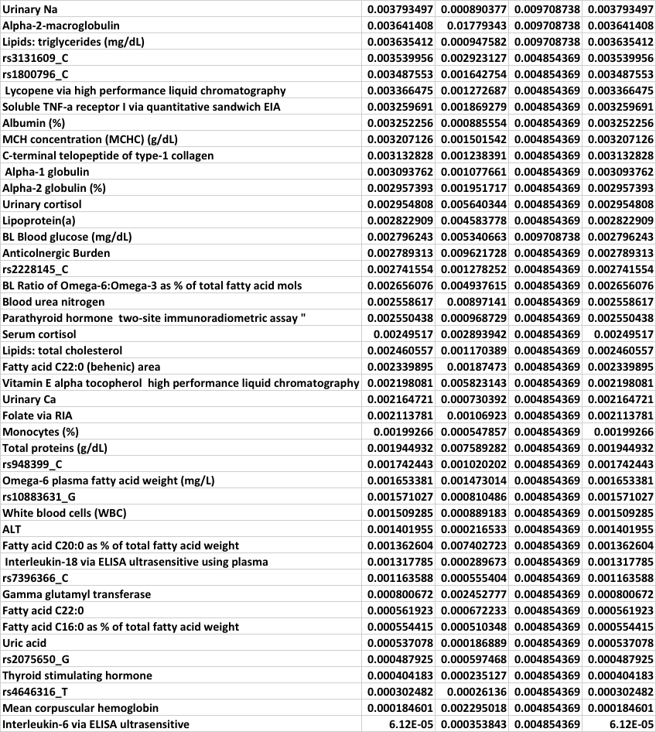

**Table V: Frailty Features Model I**

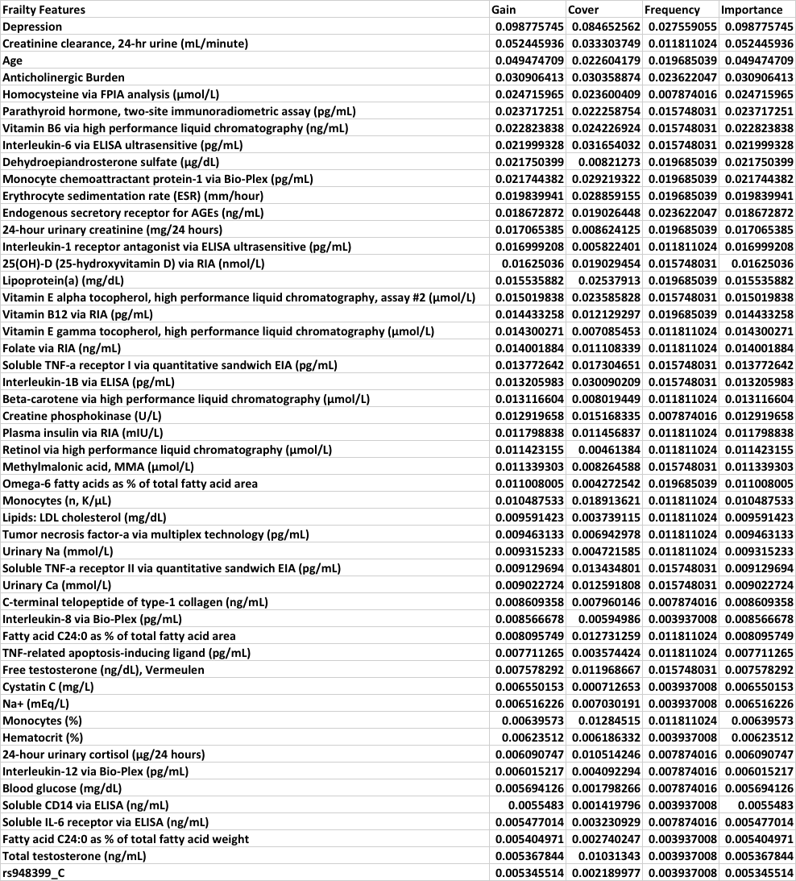

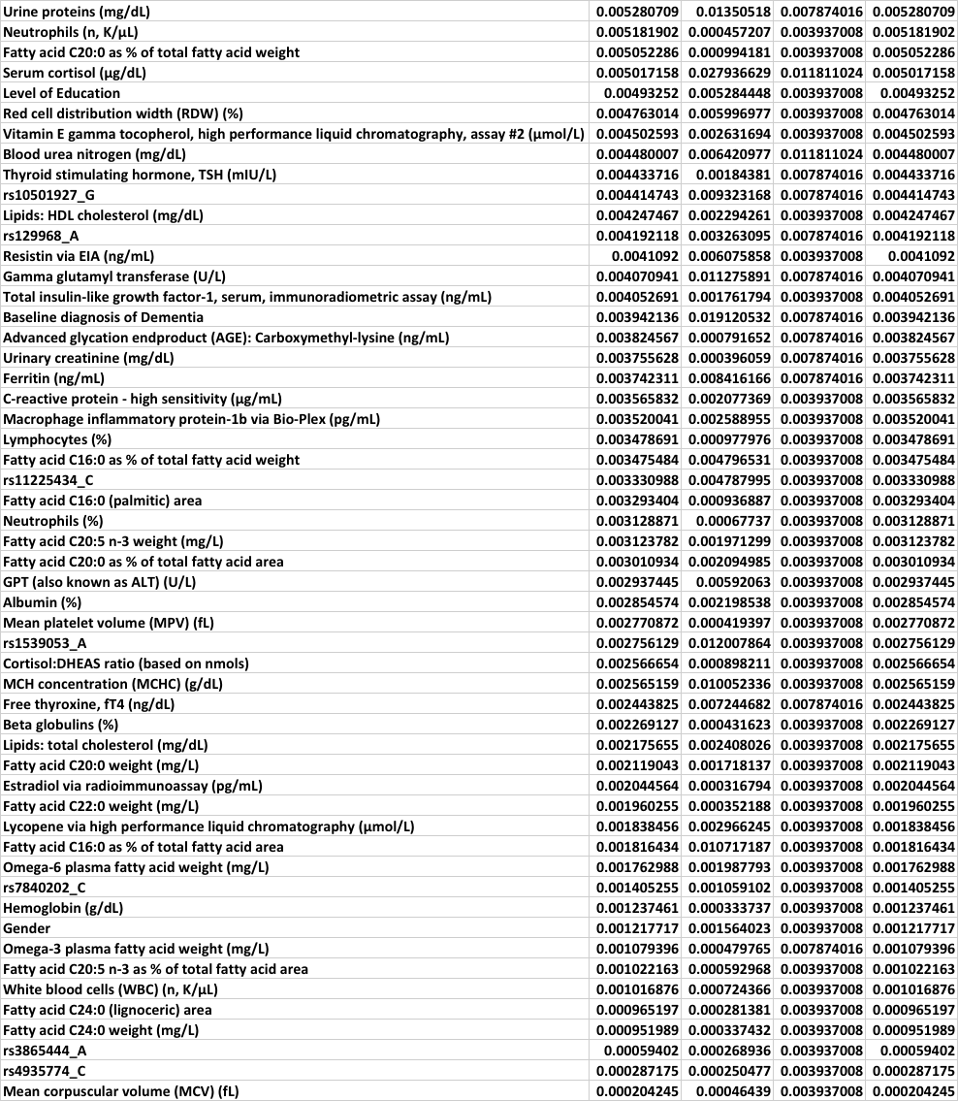

**Table VI: Cognitive Frailty Features Model I**

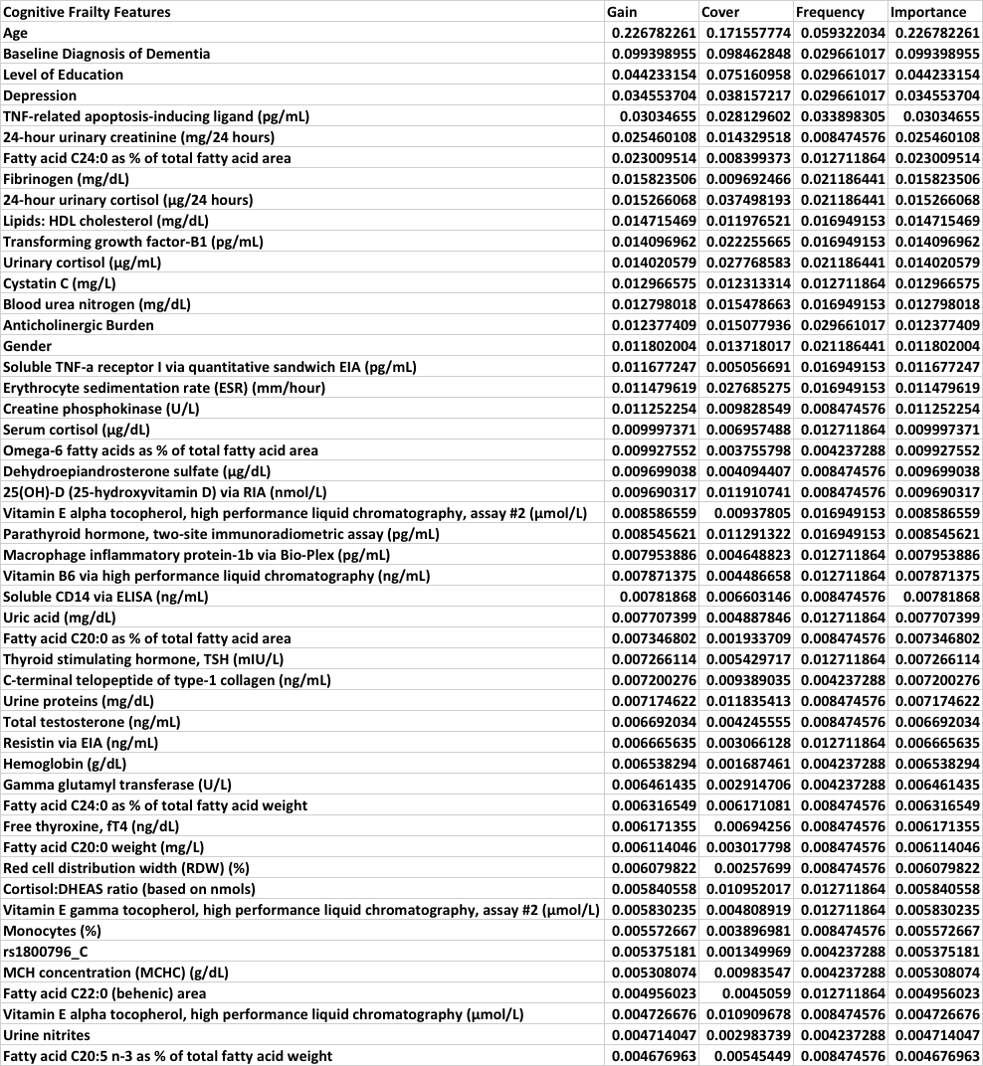

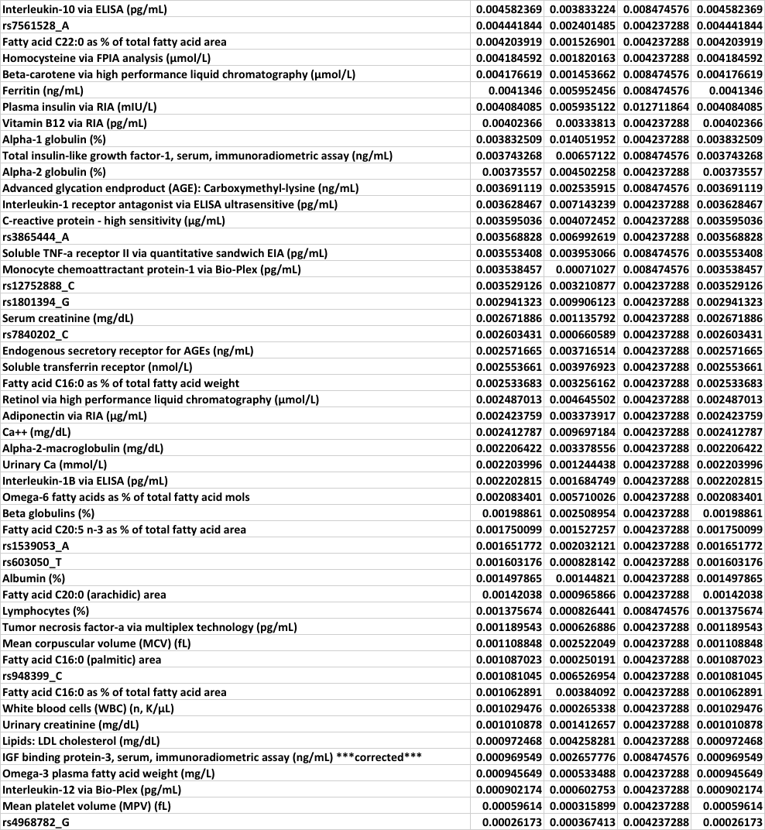

**Table VII: Cognitive Decline Features Model II**

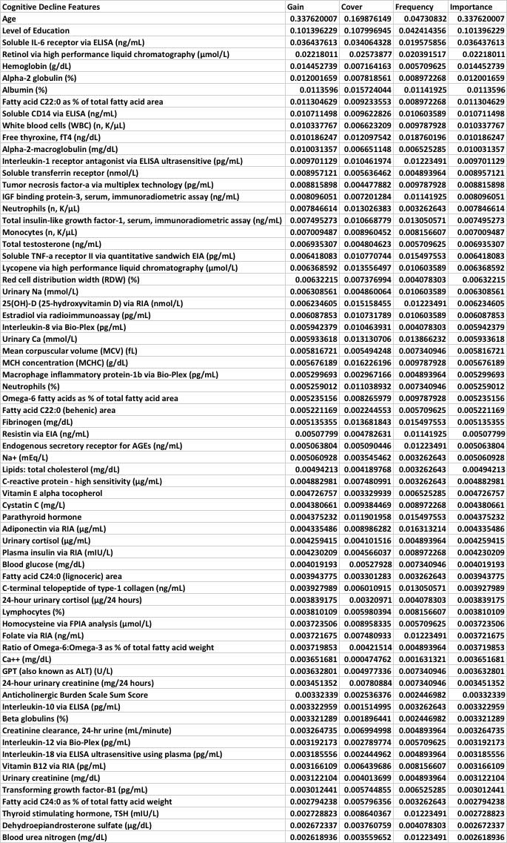

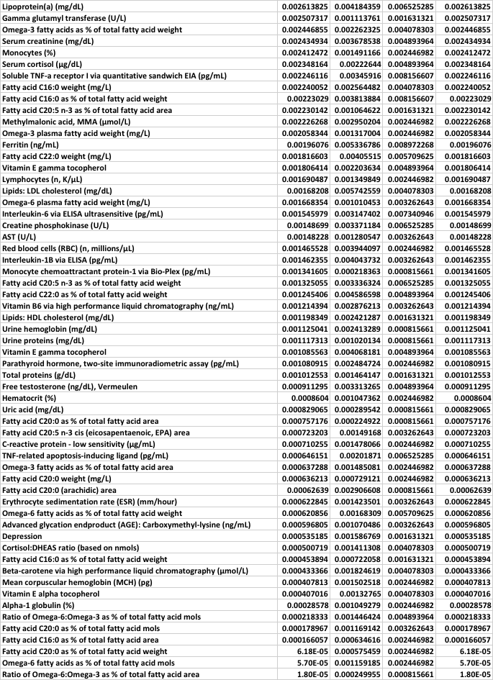**Table VIII: Frailty Features Model II**

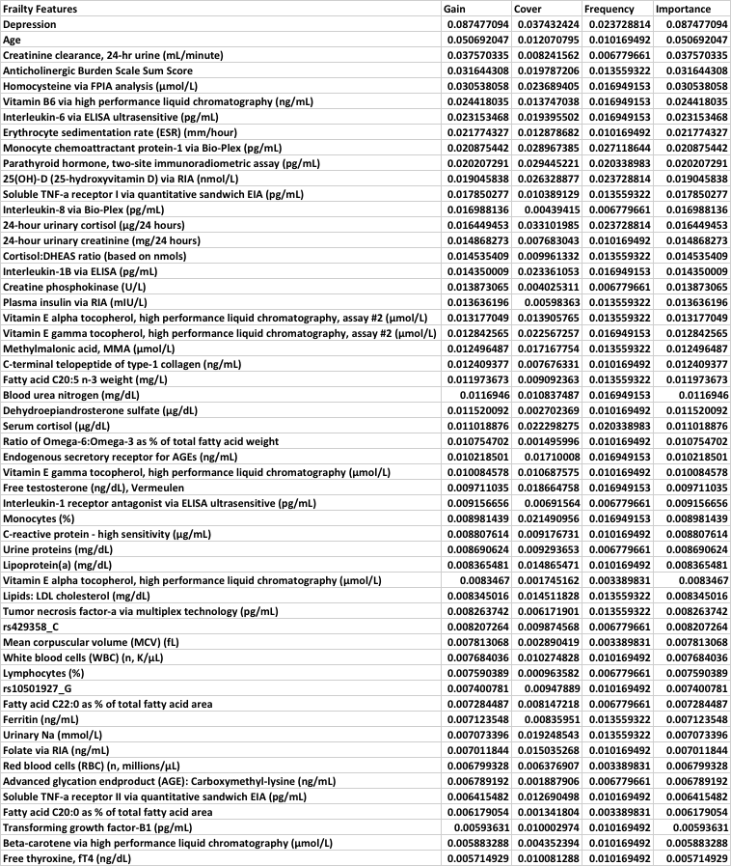

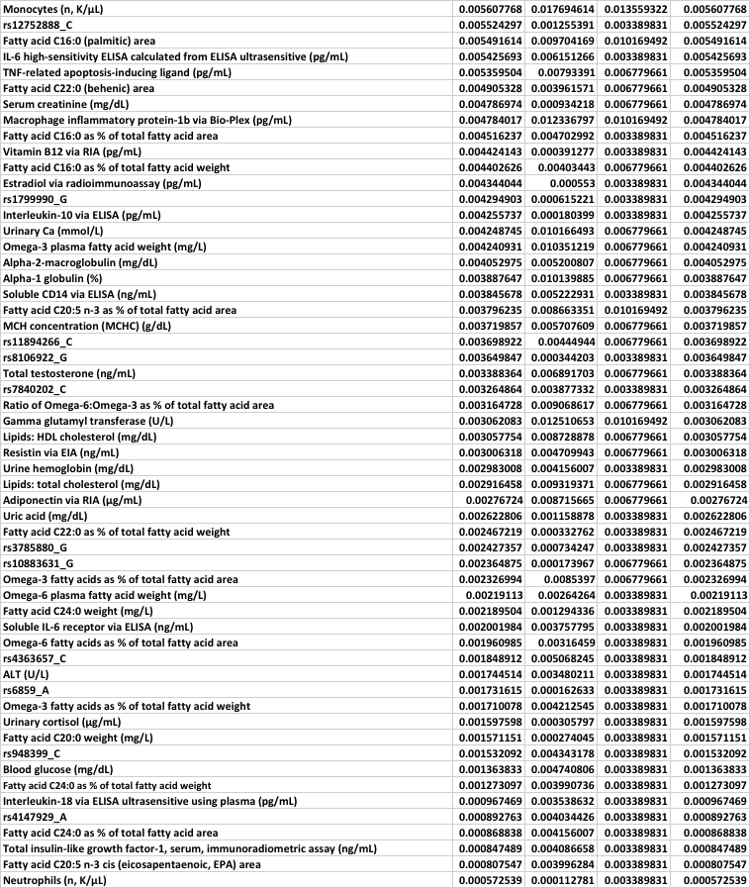

**Table IX: Cognitive Frailty Features Model II**

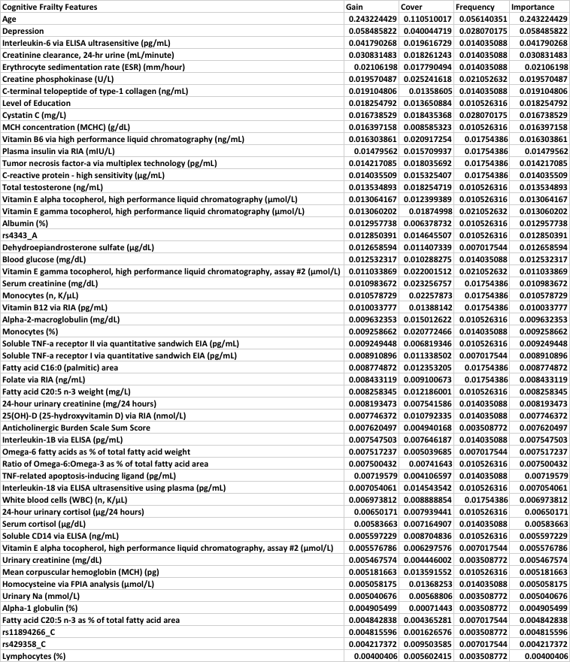

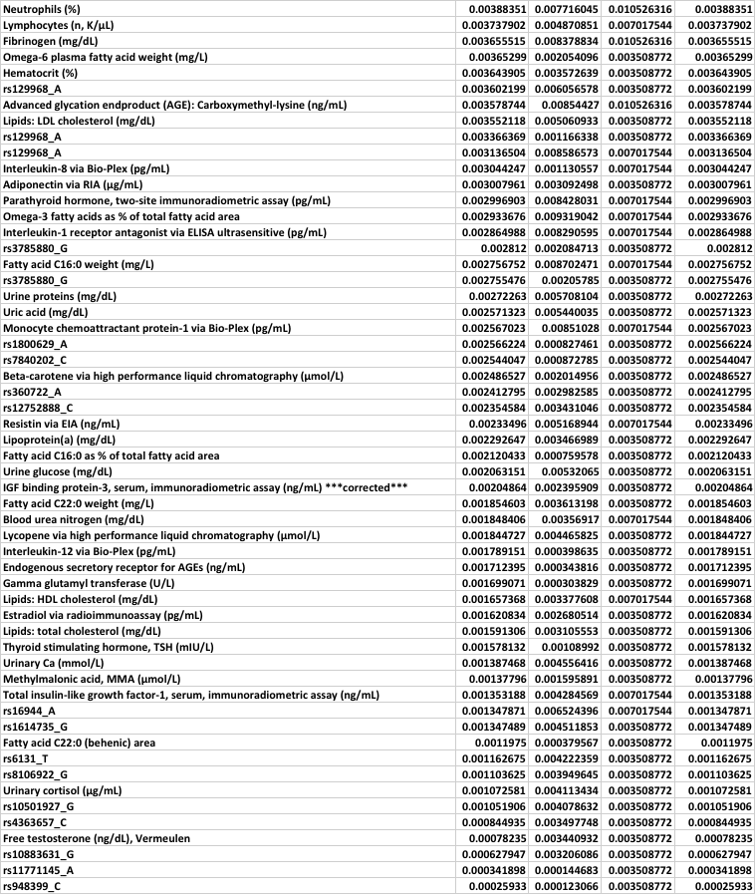

**Table X. Genomic univariate results Model I**

**

*Note:* bold text indicates the closes gene

**Table XI. Genomic univariate results Model II**

**

*Note:* bold text indicates the closes gene

**Table XII. Significant difference between health control and cognitive decline results Model I**



**Table XIII. Significant difference between healthy control and frailty results Model I**



**Table XIV. Significant difference between healthy control and cognitive frailty Model I**



**Table XV. Significant difference between healthy control and cognitive decline Model II**





**Table XVI. Significant difference between healthy control and frailty Model II**



**Table XVII. Significant difference between healthy control and cognitive frailty Model II**



References

1. Ferrucci L, Bandinelli S, Benvenuti E, et al. Subsystems Contributing to the Decline in Ability to Walk: Bridging the Gap Between Epidemiology and Geriatric Practice in the InCHIANTI Study. *J Am Geriatr Soc*. 2000;48(12):1618-1625. doi:10.1111/j.1532-5415.2000.tb03873.x

2. Millward D, Paul S, Brown M, et al. The diagnosis of asthma and exercise-induced bronchospasm in division I athletes. *Clin J Sport Med*. 2009;19(6):482-486. doi:10.1097/JSM.0b013e3181bcde2c00042752-200911000-00008 [pii]

3. Portet F, Ousset PJ, Visser PJ, et al. Mild cognitive impairment (MCI) in medical practice: a critical review of the concept and new diagnostic procedure. Report of the MCI Working Group of the European Consortium on Alzheimer’s Disease. *J Neurol Neurosurg Psychiatry*. 2006;77(6):714-718. doi:10.1136/jnnp.2005.085332

4. Simpson JR. DSM-5 and Neurocognitive Disorders. *J Am Acad Psychiatry Law Online*. 2014;42(2). http://jaapl.org/content/42/2/159. Accessed May 30, 2017.

5. Fried LP, Tangen CM, Walston J, et al. Frailty in older adults: evidence for a phenotype. *J Gerontol A Biol Sci Med Sci*. 2001;56(3):M146-56. http://www.ncbi.nlm.nih.gov/pubmed/11253156. Accessed August 27, 2014.

6. Kelaiditi E, Cesari M, Canevelli M, et al. Cognitive frailty: rational and definition from an (I.A.N.A./I.A.G.G.) international consensus group. *J Nutr Health Aging*. 2013;17(9):726-734. doi:10.1007/s12603-013-0367-2

7. Harvan JR, Cotter V. An evaluation of dementia screening in the primary care setting. *J Am Acad Nurse Pract*. 2006;18(8):351-360. doi:10.1111/j.1745-7599.2006.00137.x

8. Folstein, Marshal F., Susan E. Folstein and PRM. "Mini-mental state”: a practical method for grading the cognitive state of patients for the clinician. *J Psychiatr Res*. 1975;2.3:189-198. doi:10.1016/j.pcad.2015.11.006

9. Spering CC, Hobson V, Lucas JA, Menon C V., Hall JR, O’Bryant SE. Diagnostic accuracy of the MMSE in detecting probable and possible alzheimer’s disease in ethnically diverse highly educated individuals: An analysis of the NACC database. *Journals Gerontol - Ser A Biol Sci Med Sci*. 2012;67 A(8):890-896. doi:10.1093/gerona/gls006

10. Delrieu J, Andrieu S, Cantet C, Cesari M, Ousset P.J., Voisin T, Fougere B, Gillette S, Carrie I and VB. Neuropsychological Profile of “Cognitive Frailty” Subjects in MAPT Study. 2016;116(8):1477-1490. doi:10.14283/jpad.2016.94

11. Ashendorf L, Jefferson AL, Connor MKO, et al. Trail Making Test Errors in Normal Aging, Mild Cognitive Impairment, and Dementia. 2009;23(2):129-137. doi:10.1016/j.acn.2007.11.005.Trail

12. Marschner I. ’glm2’-Fitting GEneralized Linear Models. https://cran.r-project.org/web/packages/glm2/glm2.pdf. Accessed May 11, 2017.

13. Christensen R. ’Ordinal’- Regression Models for Ordinal Data. https://cran.r-project.org/web/packages/ordinal/ordinal.pdf. Accessed May 11, 2017.

14. Chen, Tianqi, He, Tong, Benesty, Michael, Khotilovich, Vadim, Tang Y. ’xgboost’-Extreme Gradient Boosting. 2017. doi:10.1145/2939672.2939785>

15. Purcell, S, Neale, B, Todd-Brown, K, Thomas, L, Ferreira, MAR, Bender, D, Maller, J, Sklar, P, de Bakker, PIW, Daly, MJ, Sham P. PLINK: a toolset for whole-genome association and population-based linkage analysis. *Am J Hum Genet*. 2007;81.

16. Purcell S. PLINK V1.07. http://pngu.mgh.harvard.edu/purcell/plink/. Published 2009.

17. Ferrucci L, Bandinelli S, Benvenuti E, et al. Subsystems contributing to the decline in ability to walk: bridging the gap between epidemiology and geriatric practice in the InCHIANTI study. *J Am Geriatr Soc*. 2000;48(12):1618-1625. http://www.ncbi.nlm.nih.gov/pubmed/11129752. Accessed May 31, 2017.

18. Sargent L, Nalls M, Starkweather A, et al. Shared biological pathways for frailty and cognitive impairment: A systematic review. *Ageing Res Rev*. 2018;47:149-158. doi:10.1016/J.ARR.2018.08.001